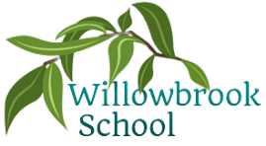

Trips

Trip to Farmwise

P.E.

Multi-skills

Swimming

Gymnastics

Science

Animals including humans

Living things and their habitats

History

Ancient Egypt

Geography

North & South Poles

Art

Drawing & painting – creating hieroglyphics

Sculpture – Egyptian amulets

Music

Lean on me & other gospel based songs

R.E

Beliefs and practices (Judaism)

What is the most significant part of the Christmas story? (Christianity)

PSHE

Feelings & emotions

A world without judgement

Being responsible

Computing

The internet

Photo editing

Autumn Term in

Year 4

French

Phonetics

I am able…

I know how…

Maths

Place value

Addition & subtraction

Area

Multiplication & division

More detailed information for individual subjects that your child will be learning will be on the school website for the corresponding half term. If you would like to know more information about any other subjects then please speak to your child’s class teacher.

English

Where the wild things are by Maurice Sendak

Firework Marker’s Daughter by Phillip Pullman

Shackleton’s Journey by William Grill