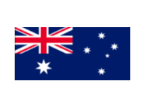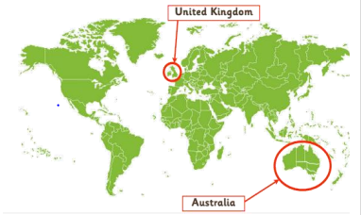 Year 2 Geography Knowledge Organiser

**Australia**

|  |
| --- |
| Context of Australia   * Australia is its own continent within the southern hemisphere * The capital city is Canberra   Large and diverse landscape   * Australia is an island and the landscape is diverse because it has so many different types of environment, e.g. mountains, coasts, rural areas, deserts, small towns/villages, cities   Weather and Climate   * Australia’s climate varies depending on which part of Australia you are in. The north is closest to the Equator and can be described as tropical (hot and humid). The south is arid (hot and dry). The very southeast and southwest are temperate (mild and moderate rain and temperature).   Population of Australia   * The first settlers in Australia are called the indigenous or Aboriginal Australians. They now make up only a small part of the population (3%). * 98% of the population live close to coastal areas. This is because coastal areas are much easier to travel around and have more resources and towns nearby which make life easier.   Cities and Daily life   * Australia’s six largest cities are: Sydney, Melbourne, Brisbane, Adelaide and Perth-Fremantle and Darwin   Science aspects   * Kangaroos and giant centipedes are examples of wildlife that live in Australia. |

