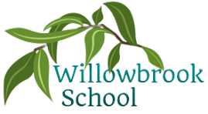

Music

Hands, feet and heart (& other South African music)

Art

Collage and silhouette pieces based on the great fire of London

P.E.

Multi-skills

Handball

Outdoor Learning

Science

Investigating living things & habitats

Geography

Brilliant Britain

History

The great fire of London

Trips/other reminders

Haldon Forest

(Date to be confirmed)

R.E

What did Jesus teach?

Jesus as a gift from God (Christianity)

PSHE

Relationships

Fire safety

Being responsible

Computing

IT around us

Pictograms (data & information)

Autumn Term in

Year 2

French

Count to 20

Say my name

Know common colours

Maths

Place value

Addition & subtraction   
Shape

More detailed information for individual subjects that your child will be learning will be on the school website for the corresponding half term. If you would like to know more information about any other subjects then please speak to your child’s class teacher.

English

The Beasties by Jenno Nimmo

The true story of the 3 little pigs by Jon Scieszka

The Enchnated Wood by Enid Blyton

The big book of the UK by Imogen Russell