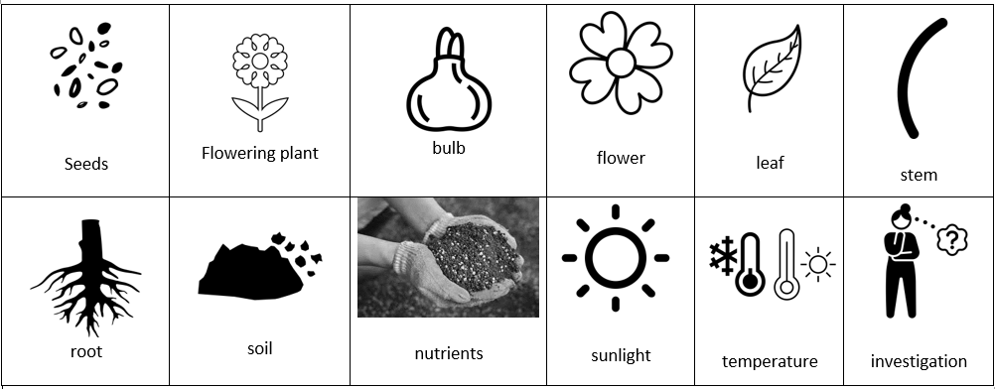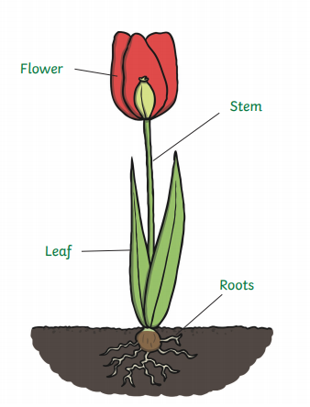Year 2 Science Knowledge Organiser   
Plants – Summer 2

|  |  |  |
| --- | --- | --- |
| Fair test Change one variable at a time. | Constant  This is the part/s we will keep the same. | Variable  This is the part of the experiment that we will change. |

   
  
Key vocabulary to know when we carry out our science experiments: