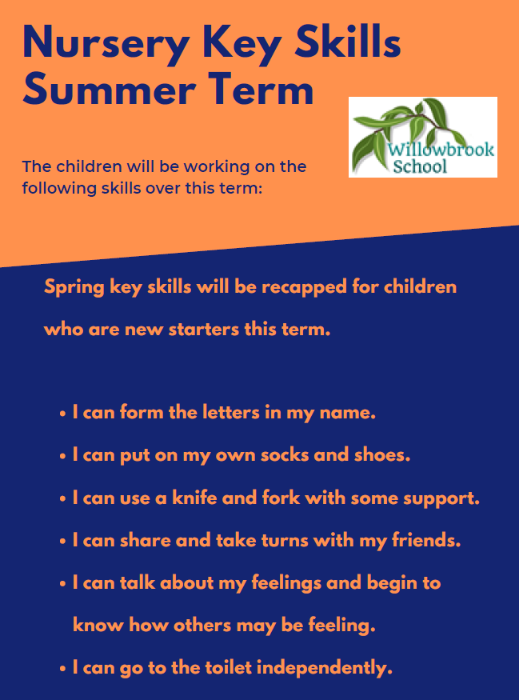

This half-term in

Nursery

Themes

Animals

People who help us

PSHE

Exploring the school theme of ‘Team work’ and ‘Health and Relationships’.

Other reminders

Please remember to bring in spare clothes and ensure your child only has water in their drinks bottle.

Nursery Rhymes

Old Macdonald

Baa baa black sheep

1,2,3,4,5

Miss Molly had a dolly

Humpty Dumpty

Jack & Jill

Maths

Sequencing

Position (on/under, in/out, in front/ behind)

Comparing groups (more than/ fewer than)

2D/3D shapes

Subitising 3

Counting to 5

English

‘Dear Zoo’- Rod Campbell

Farmer Duck by Martin Waddell and Helen Oxenbury

The Odd Fish – Naomi Jones

Look what I found at the Seaside – Moira Butterfield

Dinosaur Roar

Rumble, Rumble Dinosaur

Emergency by Margaret Mayo and Alex Ayliffe

Go, go pirate boat

*“To provide a transformative educational experience that is based on deep knowledge, nurturing relationships and personal responsibility.”*