**Year 2 Science Knowledge Organiser   
Living things and their habitats**

**Key Vocabulary**

|  |  |  |
| --- | --- | --- |
| **Habitat**  The home of an animal or plant. | **Micro habitat**  C:\Users\User\AppData\Local\Microsoft\Windows\INetCache\Content.MSO\E6FA38CB.tmpThe home for an extremely small creature. | **Predator**  An animal that hints and eats another animal for energy. |
| **Prey**  An animal that is hunted by another animal for food. | **Producer**  Living things that makes their own food from the sun. | **Reproduce**  To make more, either by having babies or creating copies. |
| **Food chain**  A sequence describing how different animals and plants eat each other. | **Living things**  Things which can grow, eat, move, breathe, reproduce and get rid of waste. |  |

**Food chain**

**Prey**

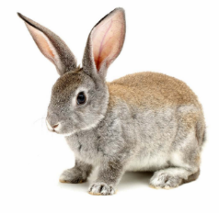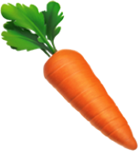

**Predator**

**Producer**

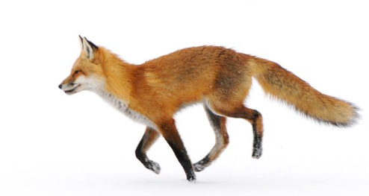

**The carrot is eaten by the rabbit. The rabbit is eaten by the fox.**

|  |  |  |
| --- | --- | --- |
| What Is a Baby Elephant Called?What Are Hardwood Trees - Harwood Vs. Softwood Tree Varieties**Living** | **Dead**  Moroccan-spiced roast chicken | Tesco Real Food100 Sheets A4 160gsm White Card - Premium Thick Printing Paper Suitable for  All Printers: Amazon.co.uk: Kitchen & HomeAutumn Leaf 3 Photograph by Gill Billington | **Never Alive**  iPhone 8 - Wikipedia**27+ Rocks Pictures | Download Free Images on Unsplash**  **Q-Line Euro Cylinder Key - Additional Cylinder Keys** |