Uses of everyday materials   
Year 2 Science – Spring 1

|  |  |  |  |
| --- | --- | --- | --- |
| wood | metal | brick | rock |
| hard, stiff, strong, opaque | strong, hard, easy to wash. | rough, strong, long-lasting. | Rough or smooth, strong, stiff and hard. |
| plastic | glass | paper | cardboard |
| Waterproof, strong, can be flexible or stiff, smooth or rough | Waterproof, transparent, hard and smooth | lightweight, flexible | Strong, light and stiff. |

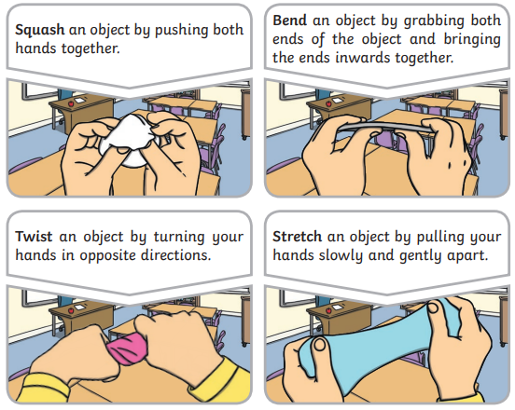

* Some materials/ objects are

man-made and some are natural.

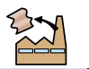

* Some can be recycled.

|  |  |  |
| --- | --- | --- |
| States of matter | | |
| Solid | Liquid | Gas |

|  |
| --- |
| Working scientifically to carry out a fair test  Hypothesis – predicting what the results might be based on what you already know.  Variable – the thing you change in an experiment to see results.  Fair test – making sure you only change one variable. |