|  |  |
| --- | --- |
| **Vocabulary** | |
| Digestion | The breaking down of food we eat into other substances that our bodies can use |
| Salivary glands | First part of the digestive system – the smell of food triggers the salivary glands to produce saliva, which increases as you taste the food. |
| Saliva | Saliva is a watery, frothy substance, which helps break down food for swallowing. |
| Mouth | Where food enters alimentary canal and digestion begins. In the mouth, food is broken down into smaller pieces by **chewing**. |
| Teeth | Tear, cut and grind food into smaller pieces |
| Tongue | Helps mix the food and saliva |
| Oesophagus | Muscular tube (about 25cm long) which moves ingest. It connects your mouth to your stomach. The Oesophagus squeezes together (**contracts**) when we swallow to move food. |
| Stomach | Muscular organ where digestion continues. The stomach produces acid that kills many harmful microorganisms and enzymes, which further break down the food. |
| Enzymes | Special chemicals in the stomach that breakdown food so the body can absorb it. |
| Liver | Produces bile, which helps to absorb fats. |
| Gallbladder | Release bile into the duodenum when needed |
| Pancreas | Produces enzymes to break down fats, proteins and carbohydrates. |
| Duodenum | First part of small intestines. Uses bile and enzymes to break down food. |
| Small intestine | Digested food is absorbed in the small intestine. This means it passes through the wall of the small intestine into the blood stream. |
| Large intestine | Most of the food has been absorbed and all that is left is the waste material the body does not need to digest (faeces). It connects the small intestine and the rectum. |
| Rectum | Where faeces are stored – makes brain aware of needing the toilet. |
| Anus | Where faeces leave the alimentary canal |

|  |
| --- |
| The Digestive System   * A series of organs that breaks the food down so it can be absorbed into our bloodstream. * The system begins as soon as food enters our mouths. * We can keep our digestive system healthy by eating the right amount of fibre, which can be found in fruit and vegetables. * Without the digestive system, we would not be able to absorb food in our bodies. |

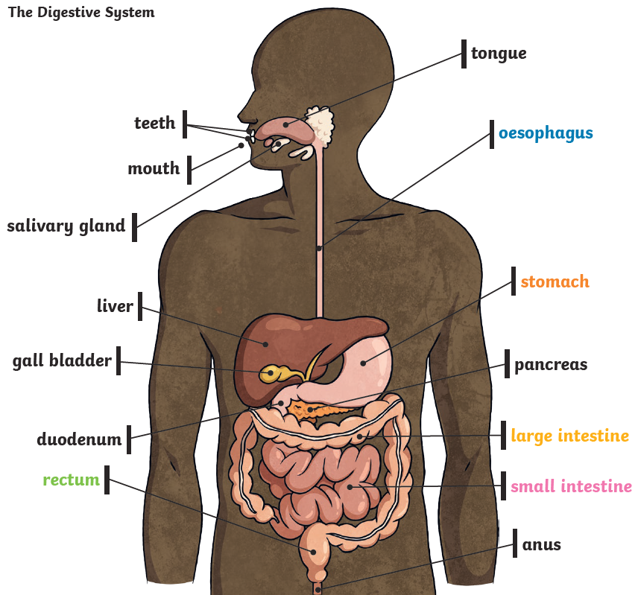

Tooth decay

Tooth decay is the destruction of your tooth enamel

Plaque, a sticky film of bacteria, forms on your teeth

Sugary drinks, sweet/salty foods or a lack of regular brushing can all cause decay

