Y2 Autumn 1 Knowledge Organiser: The Great Fire of London 1666

Key People
  Thomas Farriner | Thomas Farriner was the owner of the bakery on Pudding Lane where the fire started.
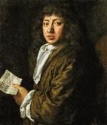  Samuel Pepys | Samuel Pepys kept a diary which tells us about what happened during The Great Fire of London.
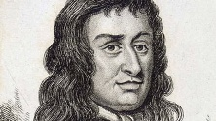  Lord Mayor  (Sir Thomas Bloodworth) | The Lord Mayor was the leader of London at the time of the fire.
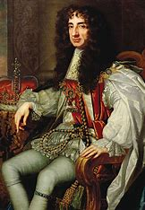  King Charles II | King Charles II was King in 1666
Key Vocabulary
Architects   | Someone who plans, designs and builds structures
Diary | A book that people write about their lives in
Flammable  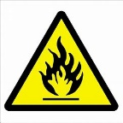 | When something burns easily
Escape | Leaving danger
Eyewitness   | A person who has seen something and can describe it
Fire
Key Places
Pudding Lane
River Thames

St Paul’s Cathedral
