|  |  |
| --- | --- |
| Vocabulary | |
| **City** | A large human settlement that often has a cathedral. |
| **Town** | A human settlement but is smaller than a city. |
| **Village** | A human settlement but is less built up, with fewer houses/ shops/ amenities. It is smaller than a town. |

Year Two Geography Knowledge Organiser  
Forest vs City – Summer 2

**Man-made** environments are created by humans.

(e.g. city)

**Natural** environments occur naturally, not artificially.

(e.g. forest).

(e.g. city).

|  |  |  |  |  |
| --- | --- | --- | --- | --- |
| mountain | These Spectacular Valleys in Iran Are Truly Worth Visitingvalley | river | vegetation | soil |
| summit | shop consumer | office | factory | Exeter Cathedral - WikipediaExeter Cathedral |

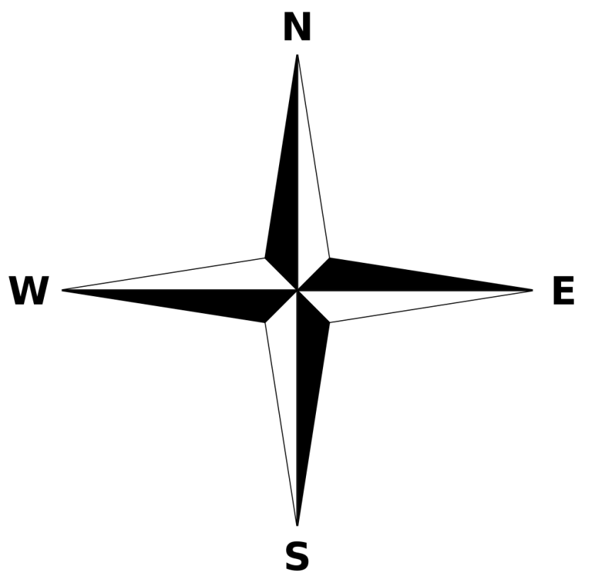

North, East, South, West