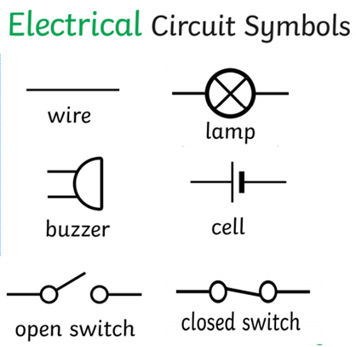

By the end of the unit we will:

1. Know how to construct simple circuits including lamps and switches.

2. Be able to identity different parts of a circuit and recognise some common conductors and insulators.

|  |  |
| --- | --- |
| Key Knowledge | |
| Electricity | Electricity can only flow as a complete circuit that has no gap. There must be wires connected to both the positive and negative ends of the power supply. |
| Know that appliances such as a kettle, iron, TV etc need electricity to run. |
| Know that a battery is a form of electrical energy, it stores the energy until it is ready to be used. |
| Know that a cell is a single unit whereas a battery is a group of cells. Both cells and batteries store electrical energy |
| know that some appliances use the mains electricity supply (the electricity that is supplied to a building externally). |

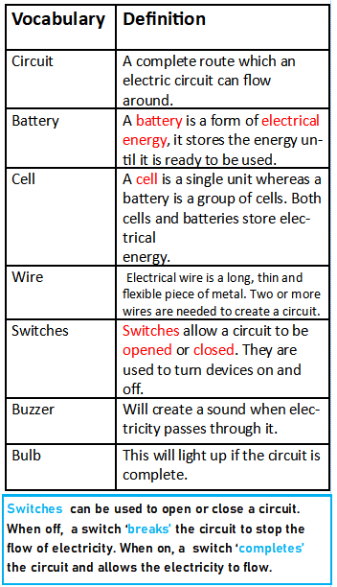

|  |
| --- |
| Circuits |
| - Know that the Latin/Greek root word ‘circ’ means ‘ring’. E.g. circle, circuit, circus.  -know that electrical components area different parts that make up an electrical circuit.  -know that two or more wires are needed to create a circuit  -know that for a lamp to light up within a simple circuit, the circuit must be complete in a loop.  -know that switches allow a circuit to be opened or closed.  -know that a lamp will not light up if the circuit is not in a complete loop.  -know that a lamp will turn on if a switch is closed and will turn off when a switch is open because the circuit is not complete.  -know that circuits can be drawn as a scientific circuit using symbols for the electrical components. Know that scientists use diagrams and symbols for circuits because it makes them easier to interpret (rather than an illustration). |

-know that a conductor is a material that allows electricity to pass through it easily.

-know that metal is a good conductor, which is why the parts of electrical appliances that need to let electricity pass through are always made of metal.

-know that an insulator is a material does not allow electricity to pass through it at all.

-know that plastic, wood, glass and rubber are all good insulators.

-know that wires are made of a metal wire inner core, covered in a plastic coating. Know that the plastic coating is an insulating material to keep us safe from the metal wire that conducts electricity.