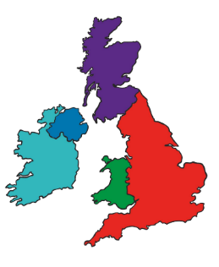Year 2 Geography Knowledge Organiser  
Brilliant Britain

|  |  |  |  |  |
| --- | --- | --- | --- | --- |
| **Country** | **Flag** | **Capital city** | **Physical features** | **Landmarks** |
| England |  | London | Generally flatter and lower than the rest of the UK. | * Buckingham Palace * Angel of the North * Big Ben * Westminster Abbey |
| Northern Ireland |  | Belfast | Mixture of uplands and lowlands and is home to the largest freshwater lake in the UK, Loch Neagh. | * Giants Causeway * The Titanic Belfast |
| Scotland |  | Edinburgh | Mountainous in the highlands with lochs, woodland and many small islands off the coast. | * Edinburgh Castle * Arthur’s Seat * The Forth Bridge |
| Wales |  | Cardiff | Mostly mountainous /hilly with wide rivers and valleys. | * Severn Bridge * Cardiff Castle * The Principality Stadium |

**Key:**

**England**

**Wales**

**Northern   
Ireland**

**Scotland**

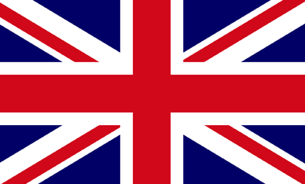

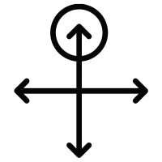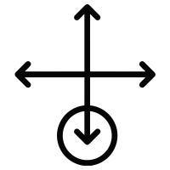

**North East South West**

**Union Jack =** the flag for the United Kingdom.