|  |  |
| --- | --- |
| **Vocabulary** | |
| Anglo-Saxon | The group of people who came over the North Sea to England after the Romans had left. |
| Viking | The group of people who came over the North Sea to England after the Romans had left. |
| Invade | To try and take over land from other people. |
| Longboat | The type of boat that the Vikings used for travelling and carrying out raids. They were long, light and slender so they could move quickly. |
| Settler | A person who moves with a group of others to live in a new country or area. |
| Angle-land | The name that the Anglo-Saxons had for England. |
| Pagan | A person who does not believe in Christianity or other main religions, but worships lots of different gods. |

**The 7 Anglo-Saxon Kingdoms**

|  |
| --- |
| TIMELINE |

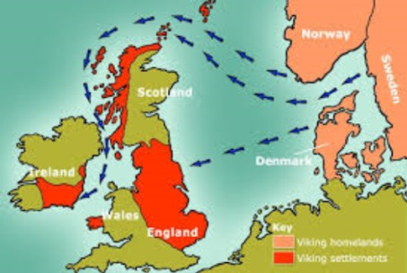 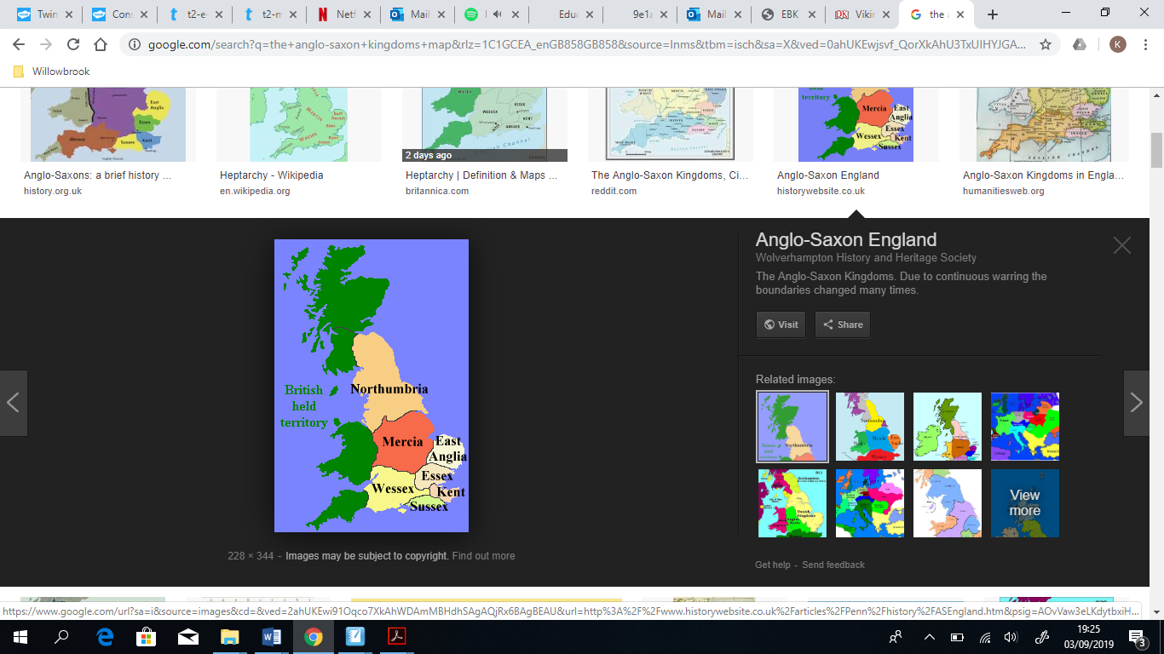

**AD 886** – Alfred the Great makes a deal with the Vikings, giving them the East and keeping the West

**Anglo-Saxon Facts:**

TheSaxons were made up of a mix of tribes from Germany, Denmark and the Netherlands. The three biggest tribes were the Angles, Saxons and the Jutes.

The exact reason why the Anglo-Saxons invaded is unknown, but there are 4 main theories. Some people believe that they were invited to defend Britain against the Scots. Others believe they came to fight. Others believe they came to farm and to make new homes as Scandinavia often flooded.

**AD 410** – The Roman Army leaves Britain. Anglo-Saxon invaders arrive in Britain

**AD 874** – The Vikings had invaded most of the Anglo-Saxon kingdoms

**AD 787** – First invasion by the Vikings

**Viking Facts:**

The word ‘Viking’ means pirate raiders.

Vikings were known as ‘Norse people’.

The Vikings were excellent craftsmen, and sailed the seas trading their goods.

The Battle of Hastings in 1066 AD ended the Viking ruling.

**Viking Invasion Map**

**AD 871** – Alfred the Great becomes King

**AD 1066** – The Battle of Hastings ends the Viking ruling